**Installing SSH Communication**

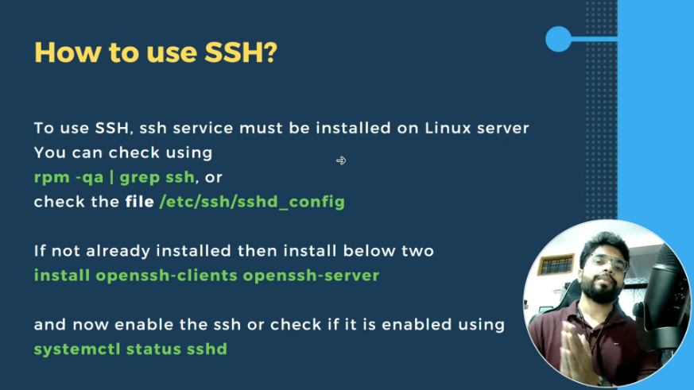

### Setting Hostnames

the **hostnamectl** command is used to both query and set the system’s hostname.

To display the current hostname, type:

# hostnamectl status

To change the hostname, use

# hostnamectl set-hostname [new hostname]

For example,

# hostnamectl set-hostname cinderella

For the changes to take effect you will need to restart the **hostnamed** daemon (that way you will not have to log off and on again in order to apply the change):

# systemctl restart systemd-hostnamed